Data Analysis Report

Concrete Compressive Strength

Contents

Acknowledgment 1

1 Description of Data 1

2 Verifying the Aspects of Data 1

2.1 Distribution and Relationship between the Variables 1

2.2 Statistical Measure 1

3 Visualization of Multivariate 2

4 Plot’s Trends and Discussion 5

# Description of Data

The most important component in civil engineering is concrete. The relationship between age and components and the compressive strength of concrete is very nonlinear. From laboratory data, the true compressive strength (MPa) of concrete for a given combination under a certain age (days) was determined. The data is unscaled and in raw form. There are 1030 instances (observations) and the 10 attributes from which eight quantitative input variables and one quantitative output variable. The response variable in this data set is concrete strength; the other eight variables—cement, fly ash, blast furnace slag, water superplasticizer, coarse aggregate, fine aggregate, and age are explanatory variables excluding the Id number. Except for age, which is expressed in days, all explanatory variables are used in m3 mixture are quantified in units of 1 kg. According to the construction theory, the first 28 days during production are when concrete can reach its maximum strength. This report illustrates multiple variables in various relationships to determine which variable significantly contributes to the attainment of concrete strength.

# Verifying the Aspects of Data

## Distribution and Relationship between the Variables

Plotting all the data produces a bell curve, which indicates that the distribution is nearly normal, so no adjustments are necessary. When using grid scatter plots, no two features appear to have a strong relation.  Despite the fact that there appears to be some association between cement and compressive strength. Furthermore, data has no significant outliers that may affect the response variable.

## Statistical Measure

Finding the Pearson Correlation coefficients gives a numerical representation of the correlations' strength, which is used to further analyse the relationship between the variables. The correlation analysis indicates that the strongest positive relationship is found between cement and compressive strength. The other variables are water, superplasticizer with strong positive correlation.

In order to determine the key variables, the linear regression model is also used. The results indicate that the variables that are significant include water, fly ash, cement, and blast furnace slag. are significant since their p-values fall below the 0.5 threshold of significance. Plotting is used with these variables to show how they relate visually.

# Visualization of Multivariate

The section explains the reasons of the plotting of these variables in this part, along.

with annotations of the plot's trends. and section 4 provides more discussion on trends. The figure 1 illustrate that cement content and age impact on concrete strength as these variables have significant impact on concrete strength according to linear regression model results.

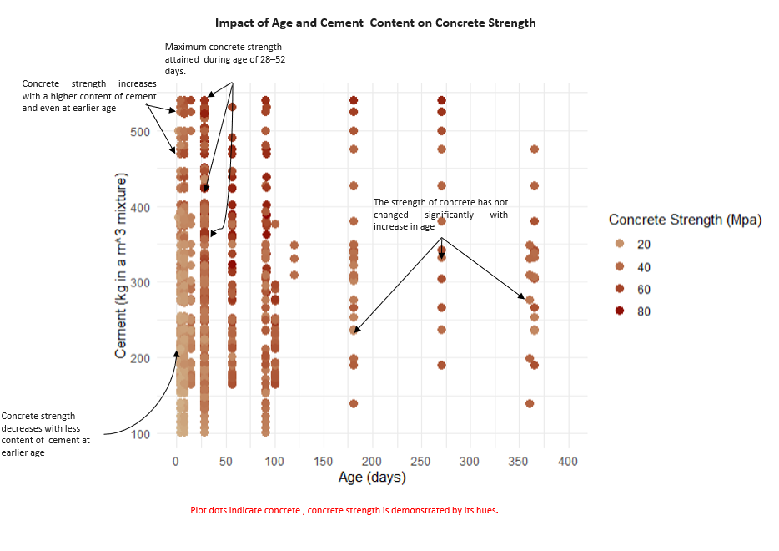

Figure 1: Impact of Age and Cement Content on Concrete Comprehensive Strength (Mpa)

In addition, cement and water have a positive correlation and are significant for the response variable concrete strength. Figure 2 illustrates the significance of water in the production of concrete for mixing, hydration, and reaching strength in early ages of concrete.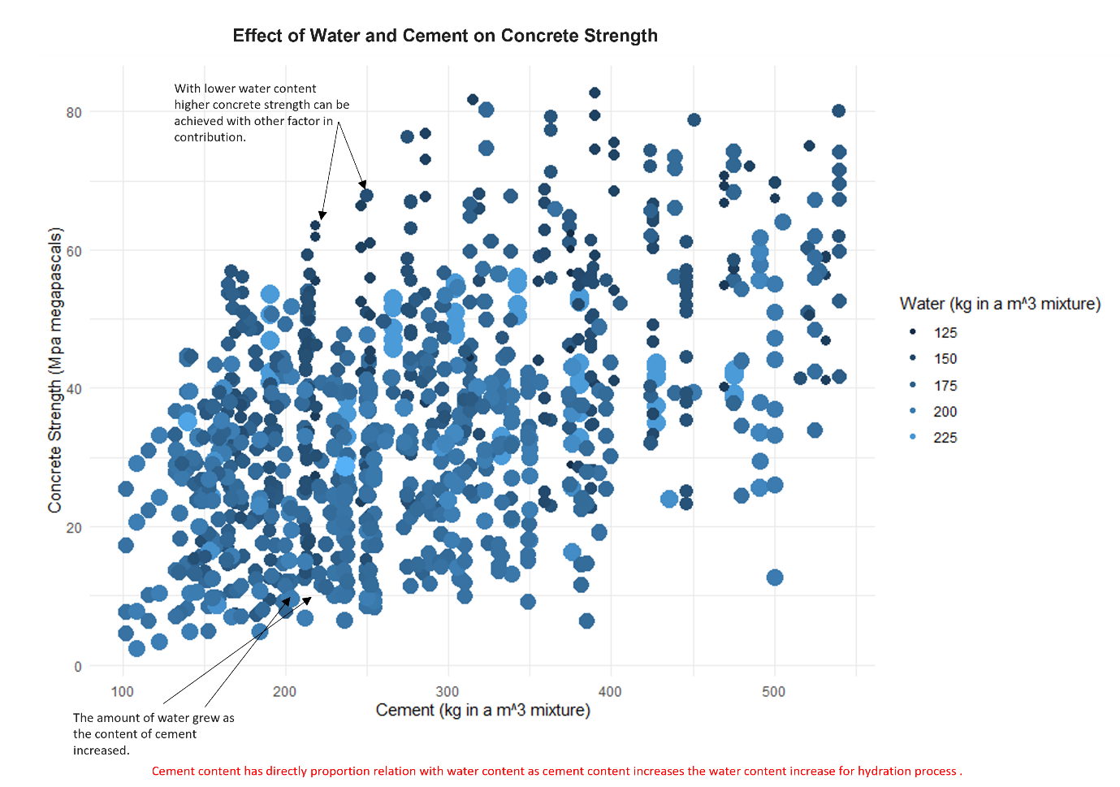

Figure 2: Water and Cement Content Compsition Impact of Concrete Strength

The fly ash is used as replacement content of cement sometimes for concrete production process. The figure 3 illustrate the use of these content and how these are used to achieve the concrete strength.

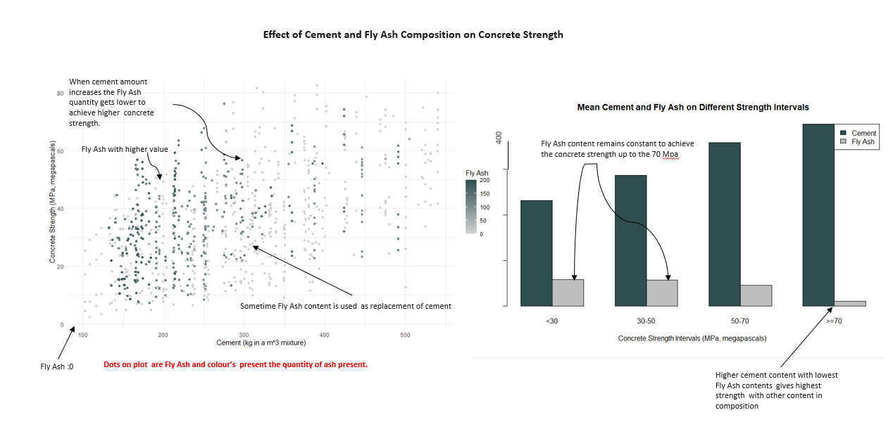

Figure 3: Cement and Fly Ash Content Composition and Their effect on Concrete Strength

The mean values of the cement, water, fly ash coarse aggregate, and fine aggregate which are relevant variables based on correlation and linear regression modelling mare shown in Figure 4 and are utilised to attain a particular concrete strength. The figures provide insight into how these components combine to give concrete its strength. 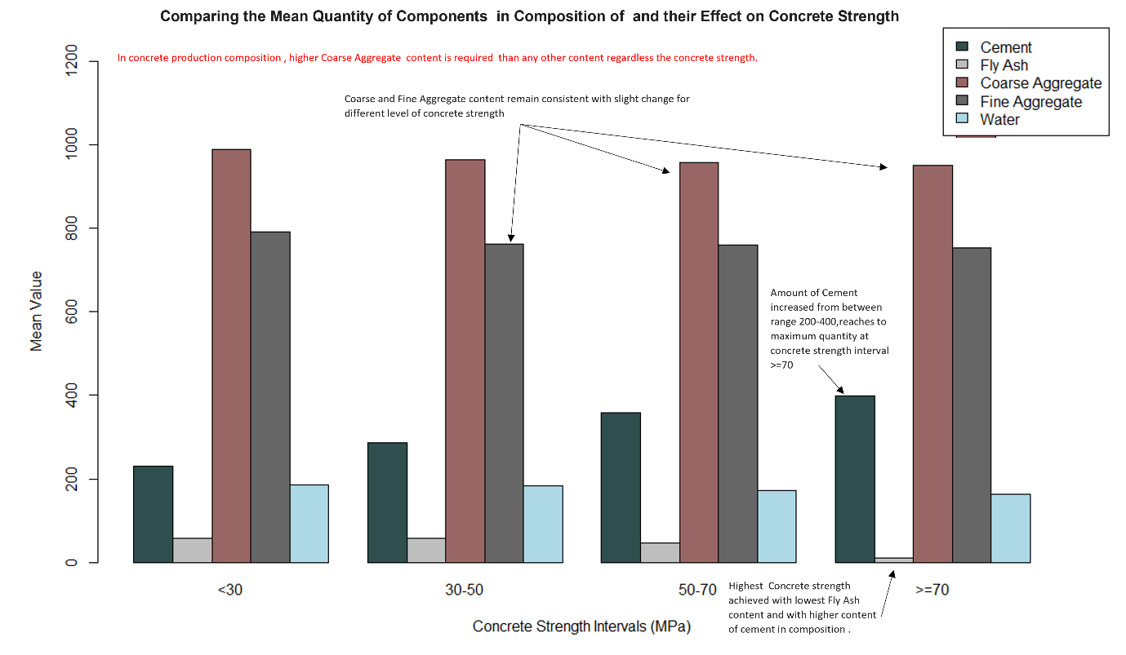

Figure 4: Comparison of Five content of Concrete Composition to Achieve the Concrete Strength (MPa)

The chemical superplasticizer is used to substitute water in the concrete-making process; if more superplasticizer is used, less water is needed, and vice versa. The chemical link between water and concrete strength is depicted in the graphs in Figure 5. The linear regression model's trend line illustrates how concrete strength increases as chemical content increases and how water content decreases as chemical content increases.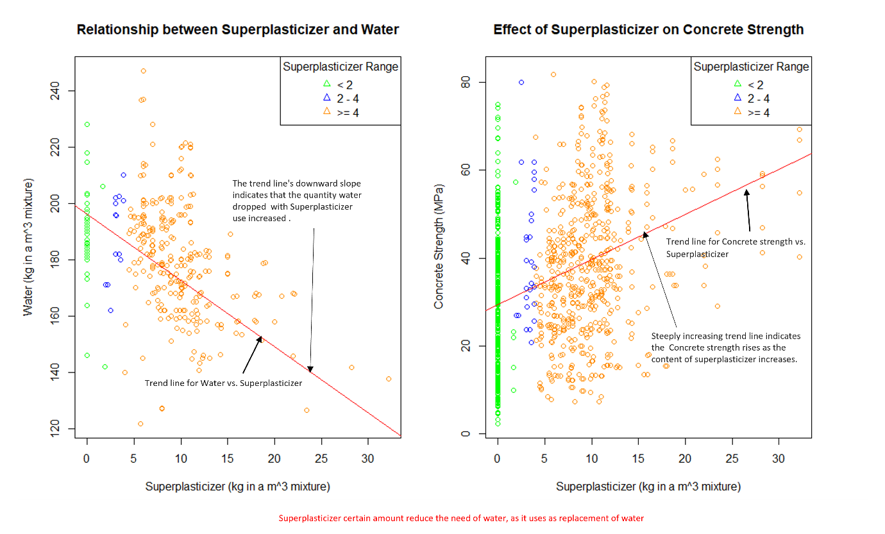

# Plot’s Trends and Discussion

From these plots following trends are observed on the relationships between these variables and compressive strength:

* Compressive concrete strength correlates positively with Cement, as cement increase in composition the strength increases even at earlier age.
* High compressive concrete strength with a low Age requires more Cement.
* Compressive concrete strength correlates positively with Age till 28 days and have significant impact on till 52 days,
* Cement tends to require more Water as it increase to mixing and keeping the concrete hydrated,
* Cement and fly ash are negatively correlates, fly ash and as fly ash composition increase the cement content reduce in composition.
* Highest Compressive Strength achieve with higher content of cement and lower content of fly ash.
* Superplasticizer negatively relate with water, increasing superplasticizer content reduces the water content.
* Compressive concrete strength increases with superplasticizer content and for most case superplasticizer higher content is between 4 to 10 kg in m^3

Based on the plot analysis, it appears that the cement content in the composition has a stronger influence on compressive concrete strength than the contents. The concrete strength shows an increasing trend as its composition have increasing cement, which is especially apparent at earlier age. It's interesting to note that more cement is needed to achieve good compressive strength at a young age. Furthermore, there is an important impact seen for up to 52 days in the positive correlation between compressive strength and age. Though 28 days have been considered to be the maximum number of days in building theory and industry to get increased concrete strength.

Higher cement and lower fly ash contents result in the highest compressive strength, emphasising the significance of these ingredients in the mixture. The significance of water in the mix is emphasised, showing that more water is needed to maintain adequate mixing and hydration of the concrete as cement content rises. Even so, superplasticizer content can, up to a point, replace water content. Similar to this, fly ash can partially replace cement in particular uses. In order to improve the strength of the concrete, a specific quantity of both fine and coarse aggregate is required. Every element in the composition is required to be present in at least the bare minimum amount. To reach the strength of the concrete, however, a particular amount of coarse and fine aggregate must be combined with more cement and water. In certain circumstances, superplasticizer and fly ash can be used in place of cement and water.